**ASSESSMENT NO. 1: BASIC DATA VISUALIZATION**

For this assessment, please open the *World Indicators* dataset in Tableau and perform the following:

1. **Line Graph**

* Generate a line graph of annual GDP of every country from 2000 to 2012
* Your final output shall show only one line representing the GDP of the Philippines. **Please post the screenshot of it below**
* Hint: Use “Filters”

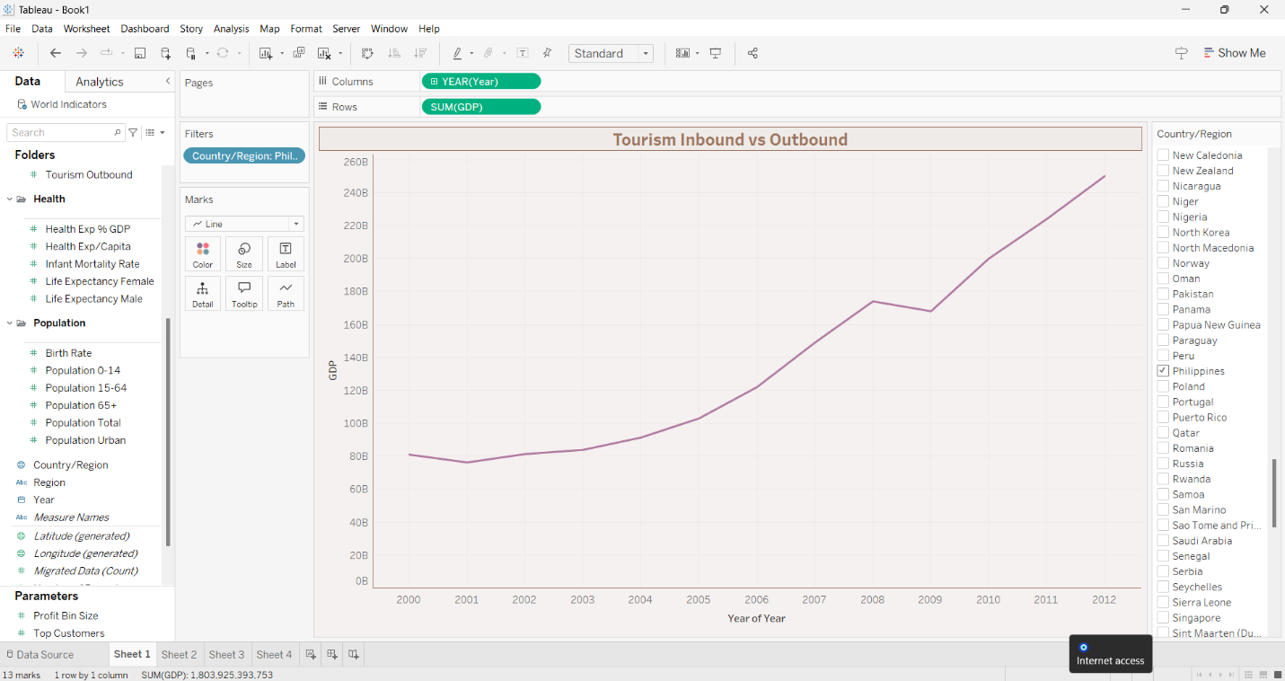

1. **Bar Graph**

* Generate a bar graph similar below. However, please modify the colors of your bars. The colors should be different from what is shown below.

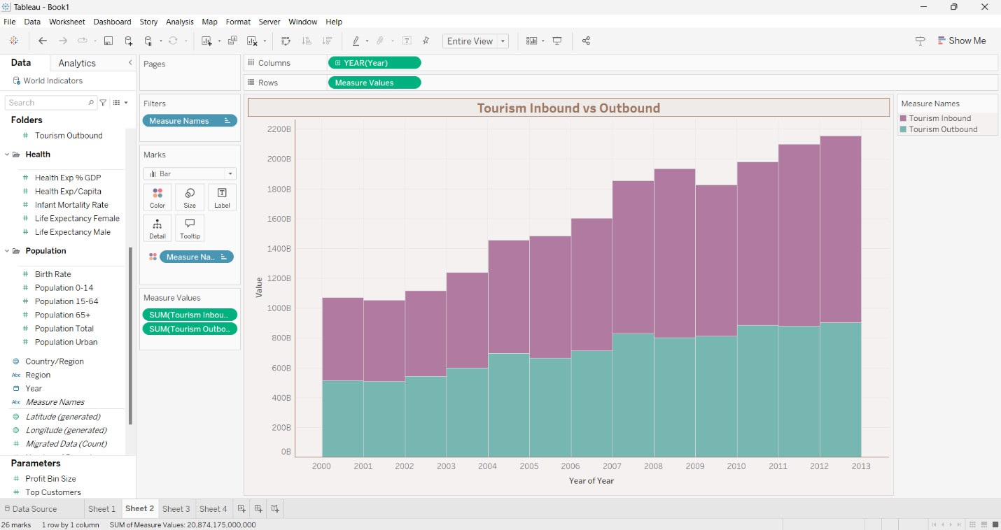

1. **Two Axis Line Chart**

* Generate a two-axis line chart for Birth Rate and Infant Mortality rate in the Philippines from 2000 to 2012

1. **Multiple Column Chart**

* Generate a bar graph like below. However, please remove the labels in the X-axis and change the colors of the bars.

